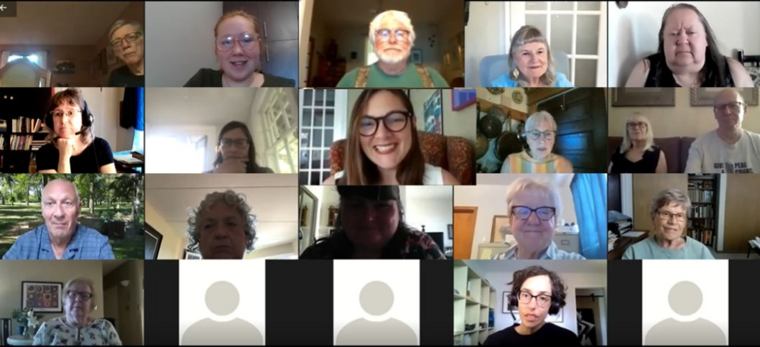

Gravel to Green:

Envisioning a plan for 409 Mulvey Ave E

Sherri Rollins, Councillor  Fort Rouge-East Fort Garry  Email: srollins@winnipeg.ca | 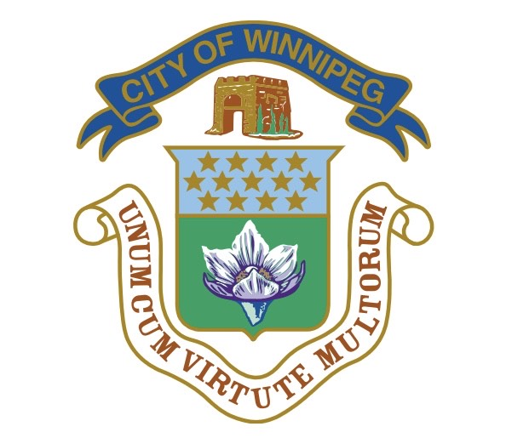

How are you connected to this space?
On a beautiful summer evening, Monday, June 28th it was amazing to see 32 people take the time out of their busy schedules to hop on a zoom call and discuss the newly saved parkland at 409 Mulvey Ave E.

The community consultation began with quick introductions where members shared how they were each connected to the parkland. Responses ranged from being able to see the area from apartment patios to experiencing the area up close as a place to walk or bike through, and if you’re lucky a chance to catch a glimpse of wildlife by the riverbank such as deer.

Community members demonstrated how beloved this area is. While showing great enthusiasm to show up and ensure an accessible and welcoming space is created that highlights the many features the space already offers.

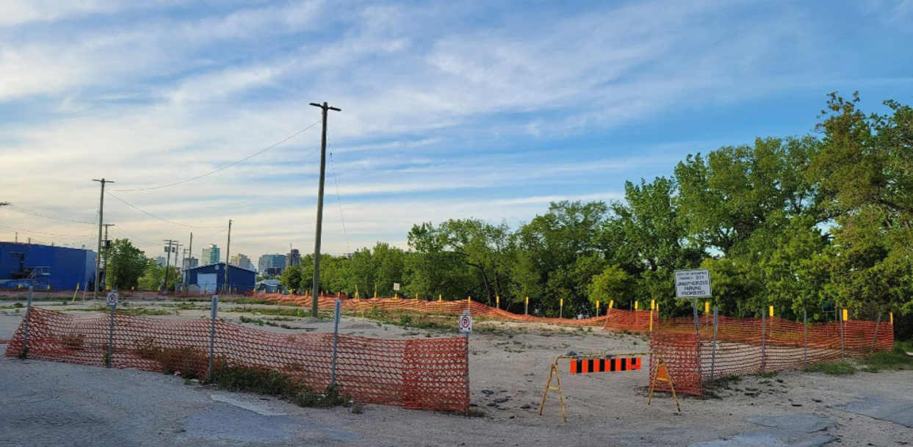
Background

409 Mulvey Ave E does not currently appear to be a piece of parkland, as layers of gravel from a prior Winnipeg Transit parking lot sit atop this parcel of land still.

This is soon to change as the exciting announcement was released at the June 28th Community meeting that $150,000 had just been invested by Winnipeg Transit! This investment will go towards hulling out the gravel with the hopes of repurposing it as well as beginning the project to remediate the soil below.

Rod Kueneman a senior scholar in the faculty of sociology at the University of Manitoba and a founding member of the Sustainable South Osborne Community Co-operative gave a brief presentation about how this soil can be revitalized and spoke to how wood chips have been used in other areas on similar projects to create soil in which trees, shrubs, and flowers could take root and prosper.

409 Mulvey Ave E sits nicely between many different amenities including a beautiful view of the river, a biking and walking path nearby, the Mulvey Flea Market right behind, and the Osborne Rapid Transit Station within a short walking distance. These adjacent pieces of infrastructure influenced many of the comments that community members made.

What are your top priorities for this space?
Once presentations and introductions were completed participants on the zoom call had the opportunity to break into smaller groups to discuss their visions for the park through the breakout room feature. The groups were given a half hour to discuss their top priorities for the park as well as the skills and talents each group member could bring to the project.

One member from each group was designated to report back.

Group 1’s ideas:
- Keep active transportation a focus - walking and cycling
- Access to the river
  - Something similar to Hugo Docks with the added possibility of walking, skating, or cycling on the frozen river
- Beautifying the area and letting nature take its course
- Planting an orchard like Rod Kueneman’s group did on the SSOC site adjacent to Riverview Hospital.
  - Growing food that could be shared
- Dog park
- Protect wildlife
  - With rules such as no fireworks along the river
- Plant Cottonwood and Poplar trees to help clean the river
- Boat launch for canoes and kayaks
Group 2’s ideas:
- Indigenous involvement from the beginning
- Meeting/gathering place
- Planting trees, shrubs, and prairie flowers
- Benches for rest and a spot to gather and talk
- Create a Habitat for Animals
- Possibility of a partnership with local business for ice cream and lemonade or other refreshments
- Make sure it is accessible for all people
- Provide winter access and for year-round use
- Public artworks
- Connection of the park to nearby trails
- Expressed possible need for a safety audit

Group 3’s ideas:
- Accessibility
  - Accessible picnic table
- Integrated with paths and the neighborhood
- Playground for children
- Educational signage that indigenizes the space and makes it a learning space which recognized Indigenous heritage
- Indigenous plants
- Natural sound barrier from parking lot, possibly a bush or some type
Group 4’s ideas:
- Green space with benches that face the river
  - To be accessible for the many 55+ buildings nearby
- Pedestrian bridge across the river
- Incorporate with biking path
- Plaque with the history of the area
- Warming house for warming up, cross country skiers, break from wind as well as a place for plants
  - Space, shade, and shelter
- Park and ride because transit is right there
- Play structure for kids
- Place for an exercise group
- Berry bushes to provide foraging opportunities
- A community survey of those who live near by
Group 5’s ideas:
- Keeping green space accessible and welcoming
- Off Leash dog park
- Business
- Public washrooms
- Intergenerational space
  - Exercise stations
  - Cycling paths
  - 3rd spaces

Ideas received by email:
- Being thoughtful about lighting by keeping in mind the nearby apartments as well as light pollution so you can still enjoy evening ambience in the space if you have firepits installed for use for example.

